Dear Parent/Guardian,

The Revolve TC competition is quickly approaching and we have created some New Revolve Competition T-Shirts! This is not obligatory, purely an option. The T-Shirts are on sale for £18 each. We are also selling Revolve Water Bottles for £12. Your child can then have their name/nickname on the back of the t-shirt/side of the water bottle as shown below (this is included in the cost).
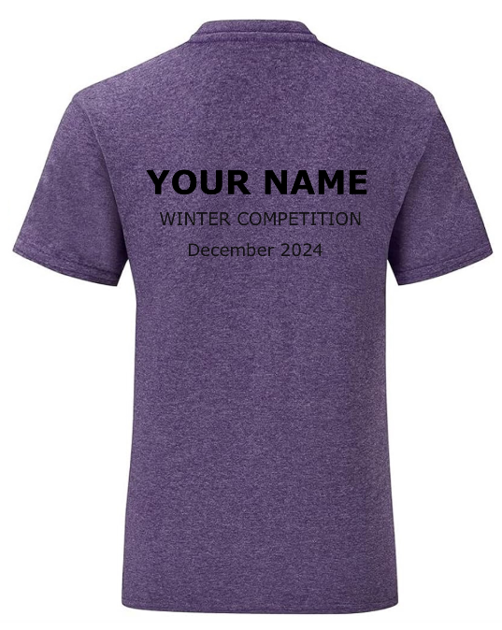
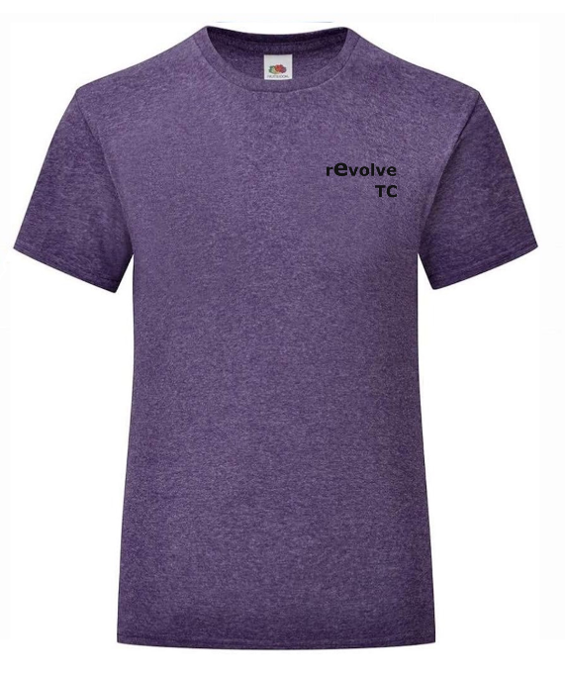
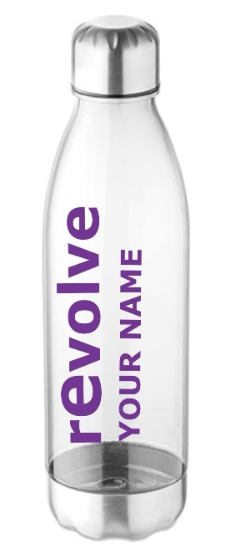

If you are interested please fill in the form overleaf,
and return it (along with payment).

DEADLINE FOR FORM IS: SATURDAY 23RD NOVEMBER

Many thanks,
Tab Baron
Revolve Trampoline Club

Name of gymnast: .............................................

CHILDRENS T-SHIRTS
(Please enquire about Adult sizes)
AGE | 3-4 | 5-6 | 7-8 | 9-11 | 12-13 | 14-15
HEIGHT (cm) | 104 | 116 | 128 | 140 | 152 | 164
CHEST (to fit) | 22/24 | 26/28 | 30 | 32 | 34 | 36
PLEASE TICK
WRITING REQUIRED ON BACK (IN CAPITALS):

.....................................................................................

WATER BOTTLES
WRITING REQUIRED ON SIDE (IN CAPITALS):

.....................................................................................

 | T-Shirt Only  (£18.00) | Water Bottle Only  (£12.00) | T-Shirt & Water Bottle Bundle  (£30.00)
PLEASE TICK

I have enclosed £............... in cash.
I have paid £............... using RTC card reader.
I have paid £............... via online banking, using the following details:
Account Name: Revolve Trampoline Club (enter gymnast’s name as reference)
Bank: Barclays
Branch: Orpington
Sort Code: 20-12-26
Account Number: 80117676

