REVOLVE TC ROUTINE SHEET

NOVICE |  | INTERMEDIATE
Lilac | Lavender | Mulberry | Mauve | Violet
Tuck Jump  Half Twist  Straddle Jump  Seat Landing  To Feet | Seat Landing  To Feet  ½ Twist Jump  Straddle Jump  Full Twist Jump  Pike Jump  ½ Twist Jump  Tuck Jump  Front Landing  To Feet | Full Twist  Straddle Jump  Seat Landing  ½ Twist to Seat Landing  ½ Twist to Feet  Pike Jump  Seat Landing  ½ Twist to Feet  Tuck Jump  Half Twist | Full Twist  Straddle Jump  Seat Landing  ½ Twist to Seat Landing  ½ Twist to Feet  Pike Jump  Back Landing  ½ Twist to Feet  Tuck Jump  Half Twist | Full Twist / BSS(T)*  Straddle Jump  Seat Landing  ½ Twist to Seat Landing  ½ Twist to Feet  Pike Jump  Back Landing  ½ Twist to Feet  Tuck Jump  FSS (T)* / Full Twist  *Routine must include one somersault
Voluntary = Repeat Set |  | Voluntary = 1.2 Tariff | Voluntary = 1.5 Tariff | Voluntary = 2.0 Tariff


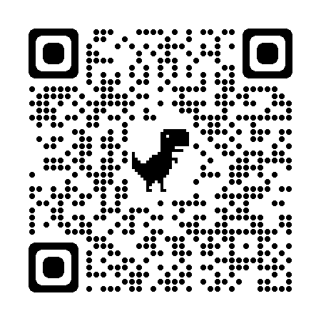
ADVANCED |  |  | ELITE
Indigo | Grape | Berry | Plum | Twilight
Back Somersault (T)  Straddle Jump  Seat Landing  ½ Twist to Seat Landing  ½ Twist to Feet  Pike Jump  Back Landing  ½ Twist to Feet  Tuck Jump  Front Somersault (T) | Full Twist  Straddle Jump  Seat Landing  ½ Twist to Seat Landing  ½ Twist to Feet  Tuck Jump  Front Somersault (T)  ½ Twist Jump  Pike Jump  Front Somersault (P) | Back Somersault (T)  Straddle Jump  BSS (T) to Seat Landing  ½ Twist to Feet  Half Twist  Pike Jump  Back Landing  ½ Twist to Feet  Tuck Jump  Full Twist | Back Somersault (T)  Straddle Jump  Barani (T)  Half Twist  Tuck Jump  Back Somersault to Seat (T)  ½ Twist to Feet  Half Twist  Pike Jump  Front Somersault (P) | Back Somersault (S)  Straddle Jump  Back Somersault (T)  Barani (T)  ½ Twist Jump  Tuck Jump  Back Somersault to Seat (T)  ½ Twist to Feet  Pike Jump  Front Somersault (P)
Voluntary = 3.0 Tariff | Voluntary = 2.5 Tariff | Voluntary = 2.5 Tariff | Voluntary = 4.0 Tariff | Voluntary = No Maximum Tariff

REVOLVE TC ROUTINE SHEET

